**Link Layer Addressing**

link-layer protocols define three types of addresses: **unicast, multicast, and broadcast**.

A unicast address represents a single device in the network.

A multicast address represents a group of devices in the network.

A broadcast address represents all devices in the network.

A unicast address **uniquely identifies a single interface by its address**. An interface can have multiple unicast addresses and must have at least one link-local address. A link-local address is an address used on a link between two nodes.

If a device want to share the information in the group, it uses the multicast address of that group. If a device want to share the information to all devices in the network, it use the broadcast address of the group.

Devices send or transmit information in small data packets, so packets can travel through any available network paths. Each data packet contains two addresses: a source address of the device creating the packet and a destination address for the device or devices intended to receive the packet.

Since only one device can create the packet, the source address in the packet always remains a unicast address. However, the destination address in the packet can be a unicast, multicast, or a broadcast address.

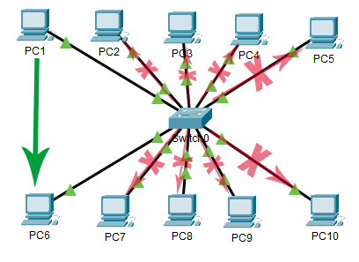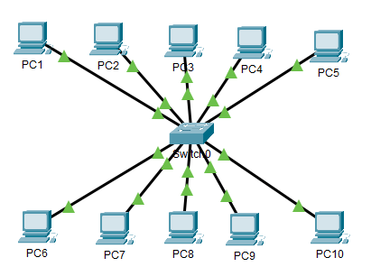

PC1 wants to send a data packet to PC6. Since the recipient of the packet is only PC6, PC1 sets the unicast address of PC6 in the destination address field of the packet. When this packet reaches all computers, except PC6, all computers discard the packet immediately. PC6 accepts and processes the packet.

When a computer receives a data packet, it checks the destination address of the packet. If it matches to the address of the computer, the computer assumes that the packet is intended for it. If it does not match to the address of the computer, the computer assumes that the packet is not intended for it. A computer only accepts the packets that are intended for it. If packets are not intended for it, it will discard them immediately.

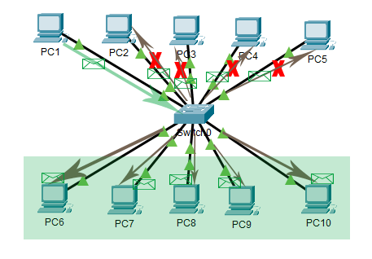

PC1 wants to send a data packet in the group. PC6, PC7, PC8, PC9, and PC10 are the member of this group. To send the data packet in this group, PC1 sets the multicast address of the group in the destination address field of the packet. When computers receive this packet, only the computers that belong to the group process the packet, the remaining computers in the network ignore it.

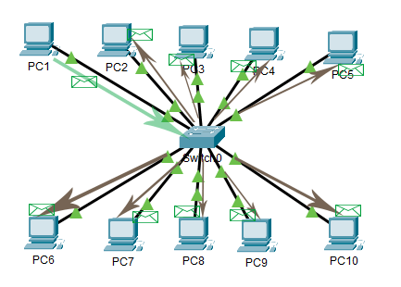

PC1 want to send a data packet to all computers in the network. PC1 sets the broadcast address of the network in the destination address field. When other computers receive this packet, they all process it.

**Address Resolution Protocol (ARP)**

Address Resolution Protocol (ARP) is a procedure for mapping a dynamic IP address to a permanent physical machine address in a local area network. The physical machine address is also known as a media access control (MAC) address.

An ARP request is sent to all devices on the Ethernet LAN and **contains the IP address of the destination host and its multicast MAC address**. If a host is ready to send a packet to a local destination device and it has the IP address but not the MAC address of the destination, it generates an ARP broadcast.